Solid Geometry - Axis of Rotation

Definition
# Source: AI Source: Provided by: [Data Path: Persons Table -> ID Column: 1, Name_En Column: Motasem Essam] -> From: [ChatGPT] on [7/25/2026]
The Axis of Rotation is an imaginary straight line around which a geometric figure, plane region, curve, or solid rotates.
In solid geometry, the axis of rotation determines the direction and position of the rotational movement used to generate a three-dimensional solid from a two-dimensional region.
When a plane region rotates around an axis, it sweeps through three-dimensional space and produces a Solid of Revolution.
The axis remains fixed during the rotation, and every point on the axis stays stationary. Points outside the axis move along circular paths centered on it.
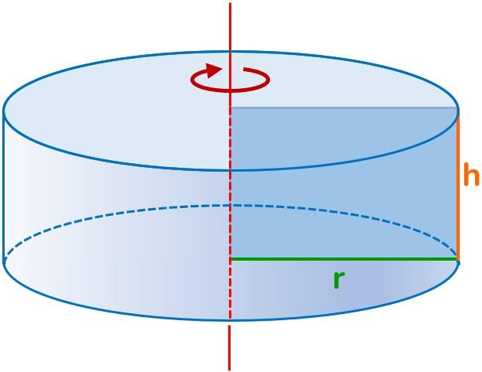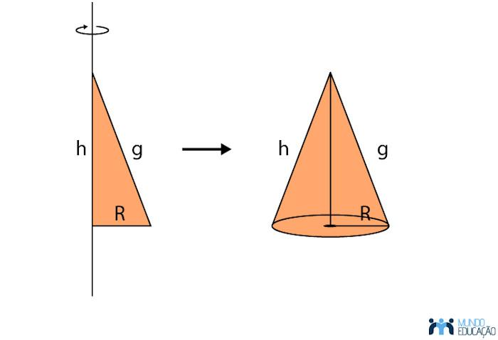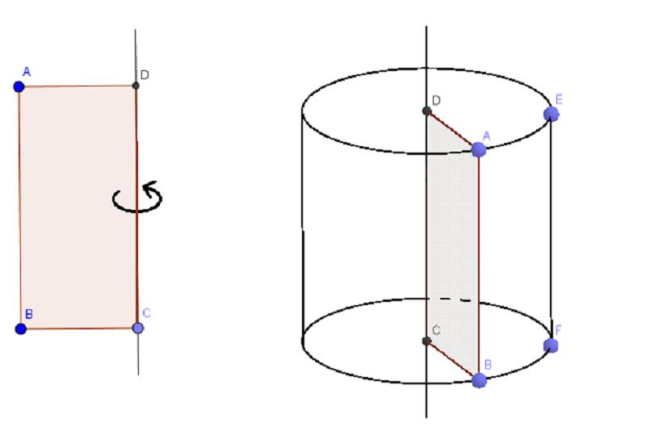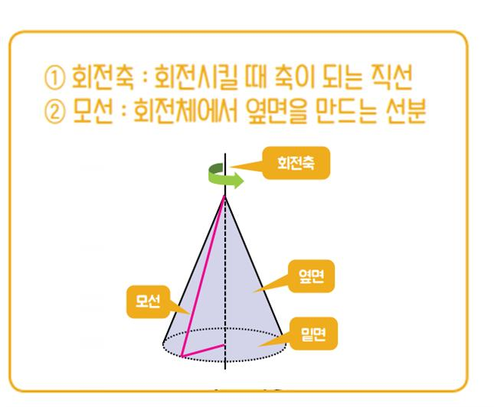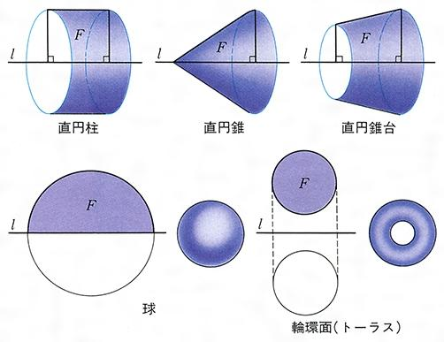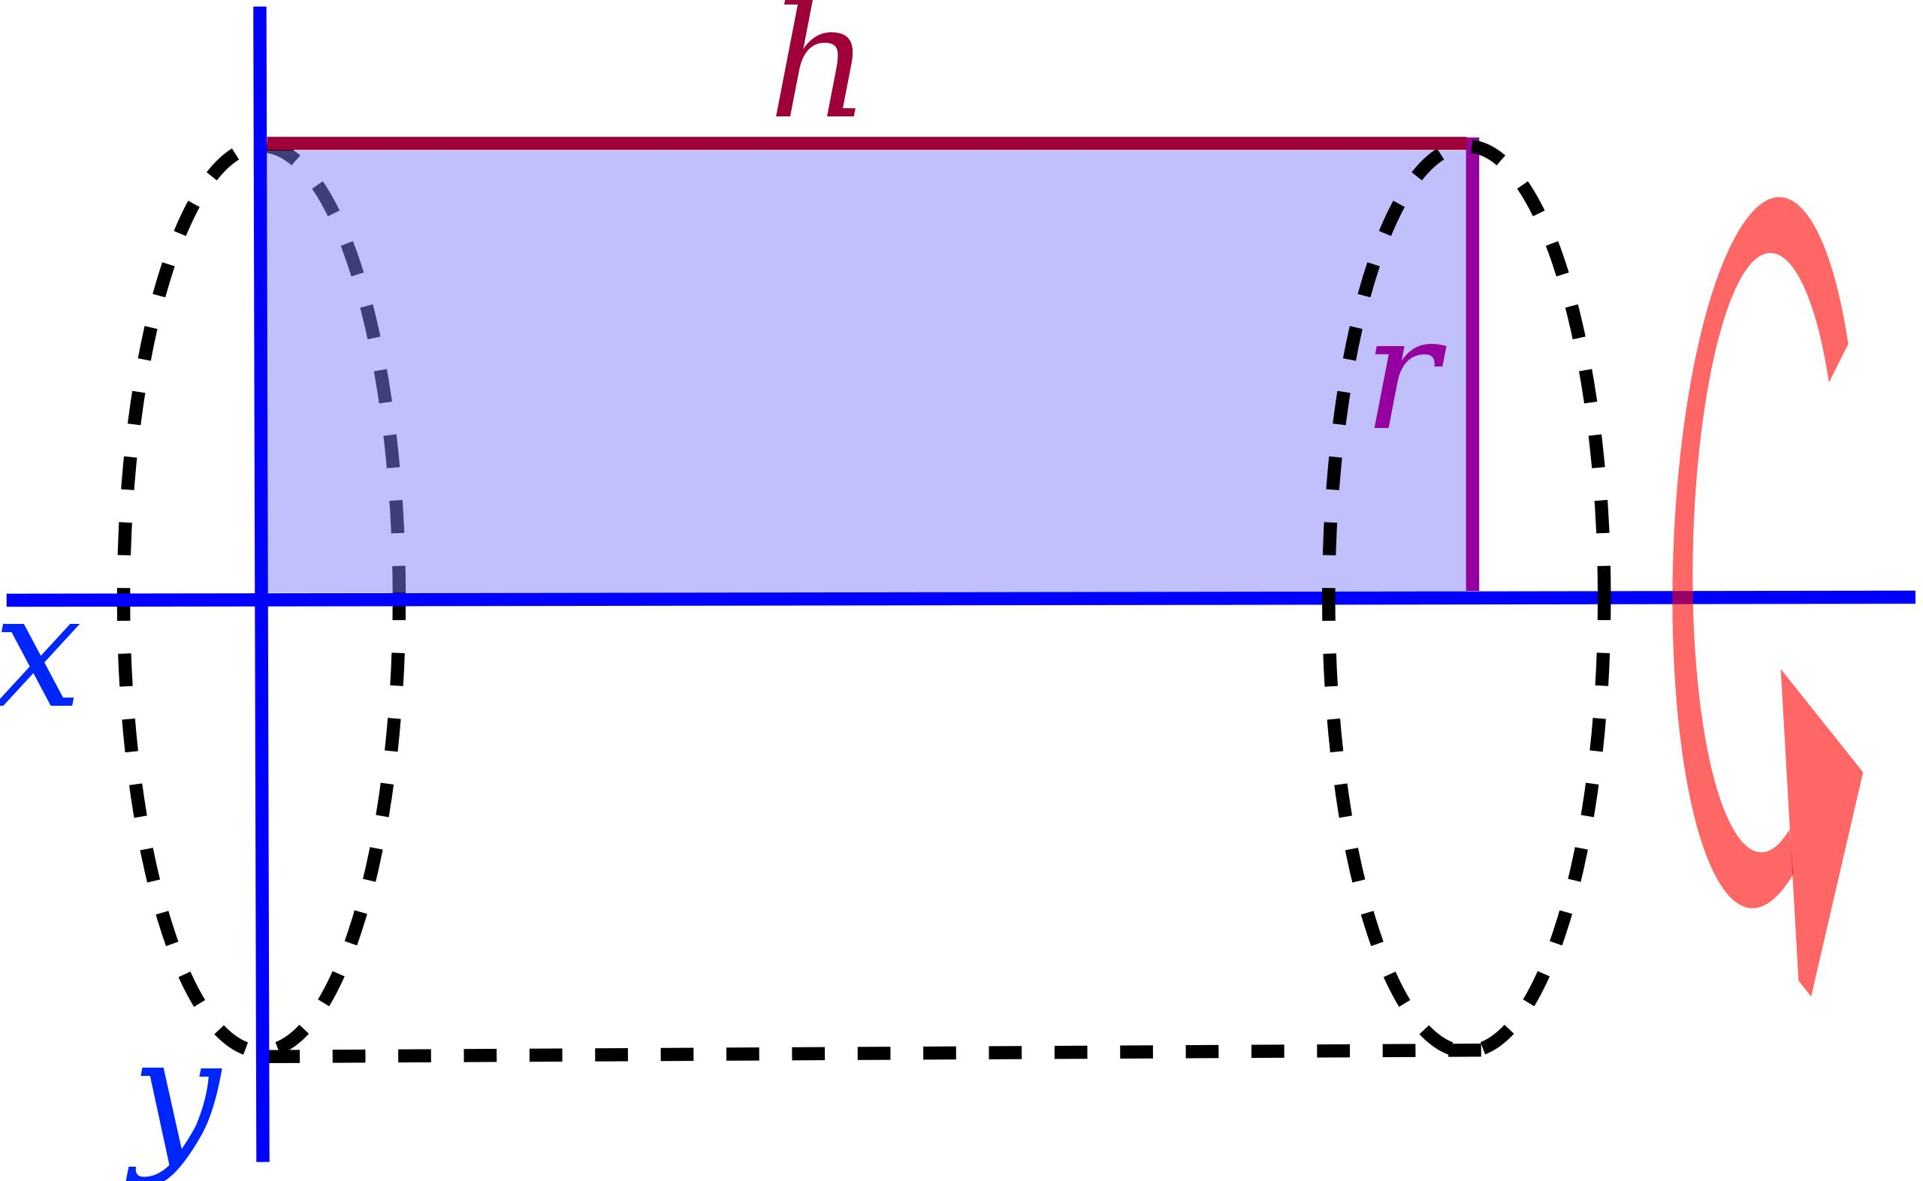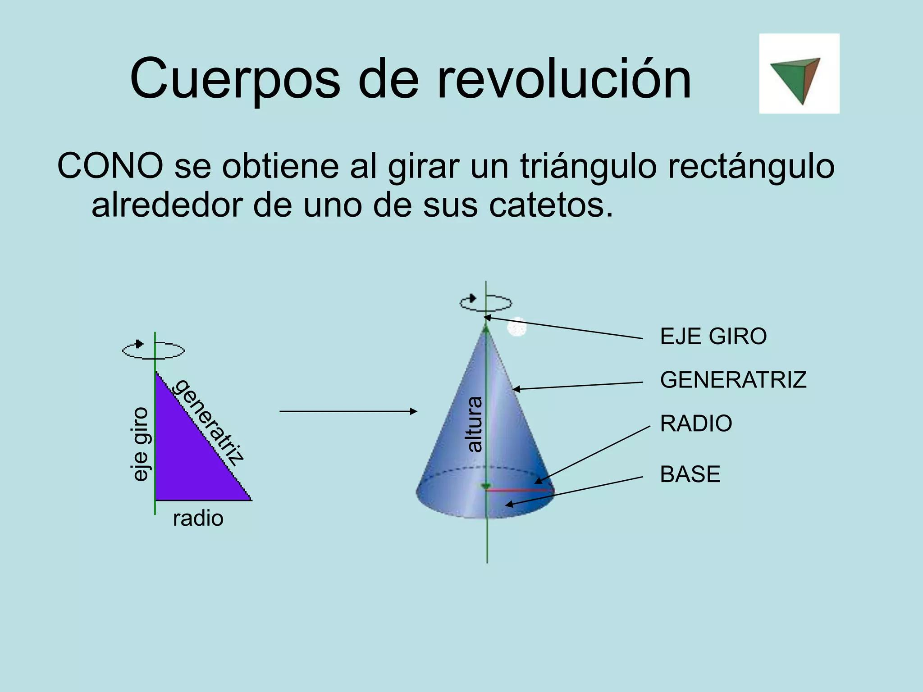

Geometric Structure
# Source: AI Source: Provided by: [Data Path: Persons Table -> ID Column: 1, Name_En Column: Motasem Essam] -> From: [ChatGPT] on [7/25/2026]
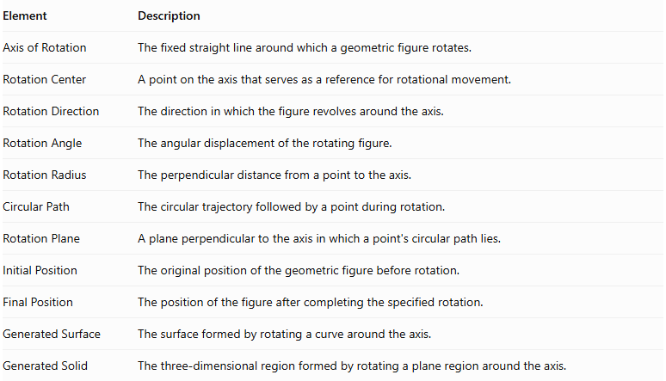
Element | Description
Axis of Rotation | The fixed straight line around which a geometric figure rotates.
Rotation Center | A point on the axis that serves as a reference for rotational movement.
Rotation Direction | The direction in which the figure revolves around the axis.
Rotation Angle | The angular displacement of the rotating figure.
Rotation Radius | The perpendicular distance from a point to the axis.
Circular Path | The circular trajectory followed by a point during rotation.
Rotation Plane | A plane perpendicular to the axis in which a point's circular path lies.
Initial Position | The original position of the geometric figure before rotation.
Final Position | The position of the figure after completing the specified rotation.
Generated Surface | The surface formed by rotating a curve around the axis.
Generated Solid | The three-dimensional region formed by rotating a plane region around the axis.

Main Characteristics
# Source: AI Source: Provided by: [Data Path: Persons Table -> ID Column: 1, Name_En Column: Motasem Essam] -> From: [ChatGPT] on [7/25/2026]
- The axis of rotation is a straight line.
- It remains fixed during the rotation.
- Every point on the axis remains stationary.
- Every point outside the axis moves along a circular path.
- The radius of a point's circular path equals its perpendicular distance from the axis.
- The axis determines the orientation and symmetry of the generated solid.
- Changing the axis position or direction can produce a different solid from the same generating region.
- The rotation can be partial or complete.

Types of Axes of Rotation According to Position
# Source: AI Source: Provided by: [Data Path: Persons Table -> ID Column: 1, Name_En Column: Motasem Essam] -> From: [ChatGPT] on [7/25/2026]
The axis of rotation can be classified according to its position relative to the generating region.

Boundary Axis of Rotation
# Source: AI Source: Provided by: [Data Path: Persons Table -> ID Column: 1, Name_En Column: Motasem Essam] -> From: [ChatGPT] on [7/25/2026]
A Boundary Axis of Rotation is an axis that coincides with one of the boundary lines or edges of the generating region.
For example, rotating a rectangular region around one of its sides generates a right circular cylinder.

External Axis of Rotation
# Source: AI Source: Provided by: [Data Path: Persons Table -> ID Column: 1, Name_En Column: Motasem Essam] -> From: [ChatGPT] on [7/25/2026]
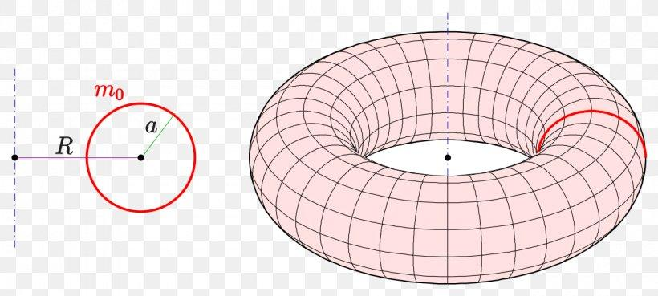
An External Axis of Rotation is an axis located outside the generating region, without passing through its interior or coinciding with its boundary.
For example, rotating a circular region around an external coplanar axis generates a ring torus when the axis does not intersect the circle.

Internal Axis of Rotation
# Source: AI Source: Provided by: [Data Path: Persons Table -> ID Column: 1, Name_En Column: Motasem Essam] -> From: [ChatGPT] on [7/25/2026]
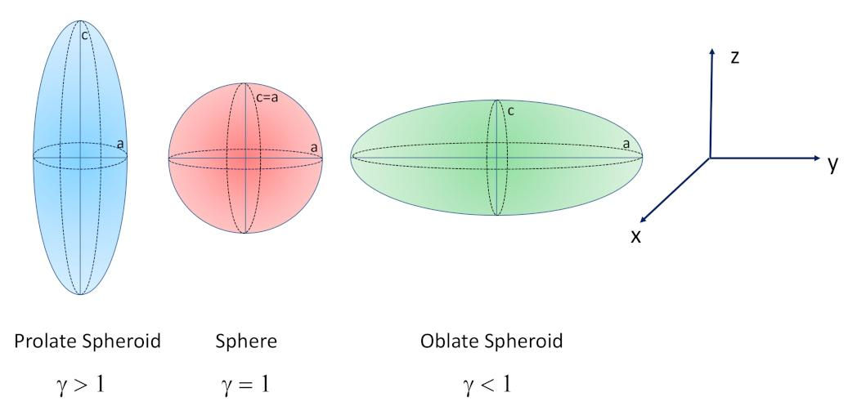
An Internal Axis of Rotation is an axis that passes through the interior of the generating region.
For example:
- Rotating a circular region around its diameter generates a sphere.
- Rotating an elliptical region around its major axis generates a prolate spheroid.
- Rotating an elliptical region around its minor axis generates an oblate spheroid.

Types of Axes of Rotation According to Direction
# Source: AI Source: Provided by: [Data Path: Persons Table -> ID Column: 1, Name_En Column: Motasem Essam] -> From: [ChatGPT] on [7/25/2026]
An axis of rotation can also be classified according to its orientation in a coordinate system.

Horizontal Axis of Rotation
# Source: AI Source: Provided by: [Data Path: Persons Table -> ID Column: 1, Name_En Column: Motasem Essam] -> From: [ChatGPT] on [7/25/2026]
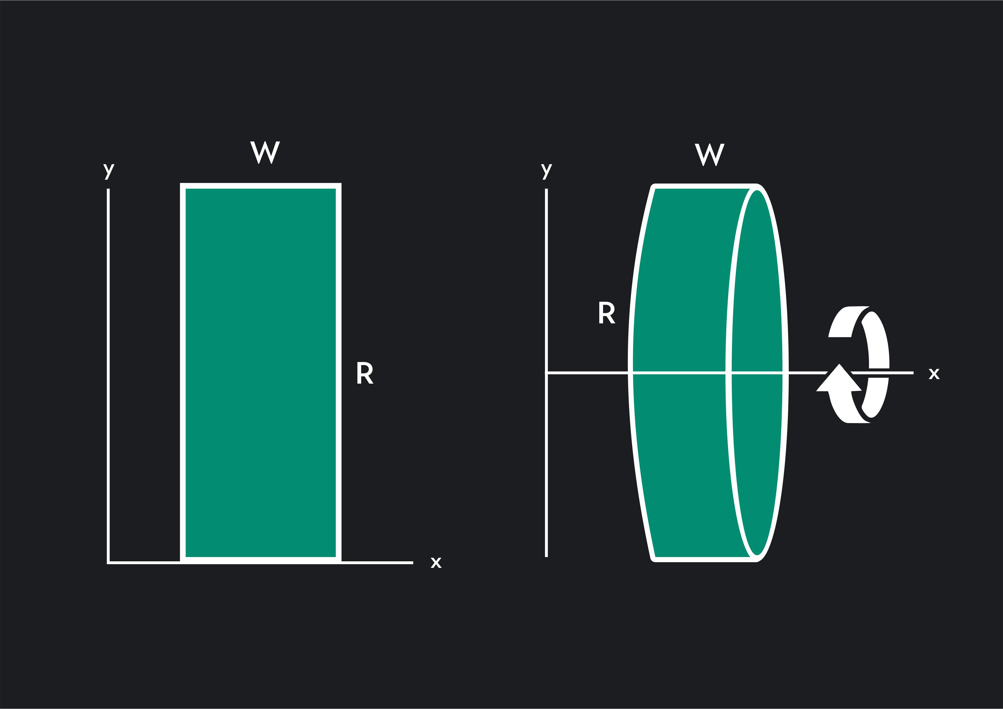
A Horizontal Axis of Rotation is an axis parallel to the horizontal direction of the coordinate plane.
Examples:
- The $x$-axis.
- A horizontal line $y=k$.

Vertical Axis of Rotation
# Source: AI Source: Provided by: [Data Path: Persons Table -> ID Column: 1, Name_En Column: Motasem Essam] -> From: [ChatGPT] on [7/25/2026]
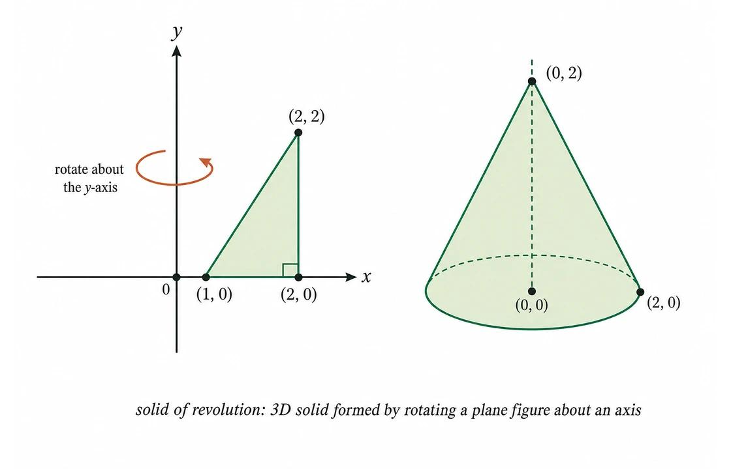
A Vertical Axis of Rotation is an axis parallel to the vertical direction of the coordinate plane.
Examples:
- The $y$-axis.
- A vertical line $x=k$.

Inclined Axis of Rotation
# Source: AI Source: Provided by: [Data Path: Persons Table -> ID Column: 1, Name_En Column: Motasem Essam] -> From: [ChatGPT] on [7/25/2026]
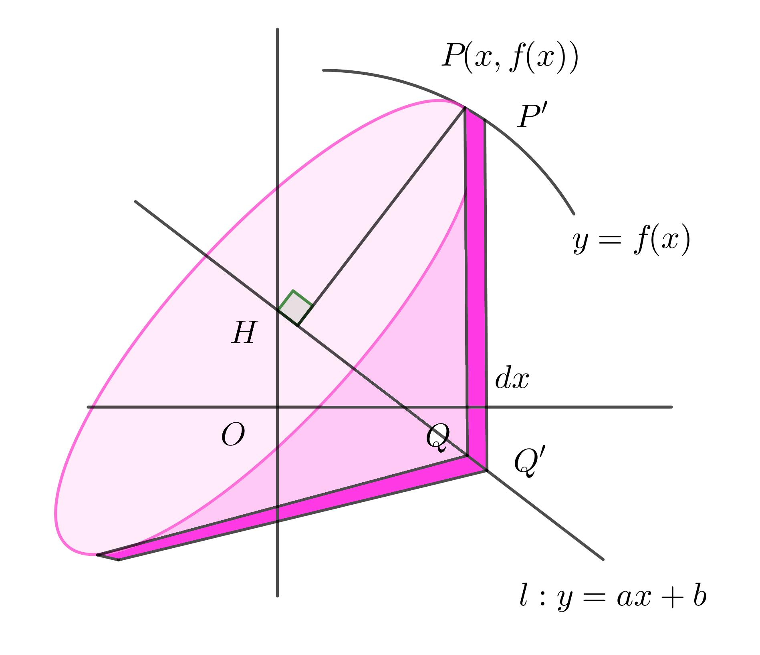
An Inclined Axis of Rotation is an axis that is neither horizontal nor vertical relative to the chosen coordinate system.
It forms an angle with the horizontal or vertical reference direction.

Arbitrary Axis of Rotation
# Source: AI Source: Provided by: [Data Path: Persons Table -> ID Column: 1, Name_En Column: Motasem Essam] -> From: [ChatGPT] on [7/25/2026]
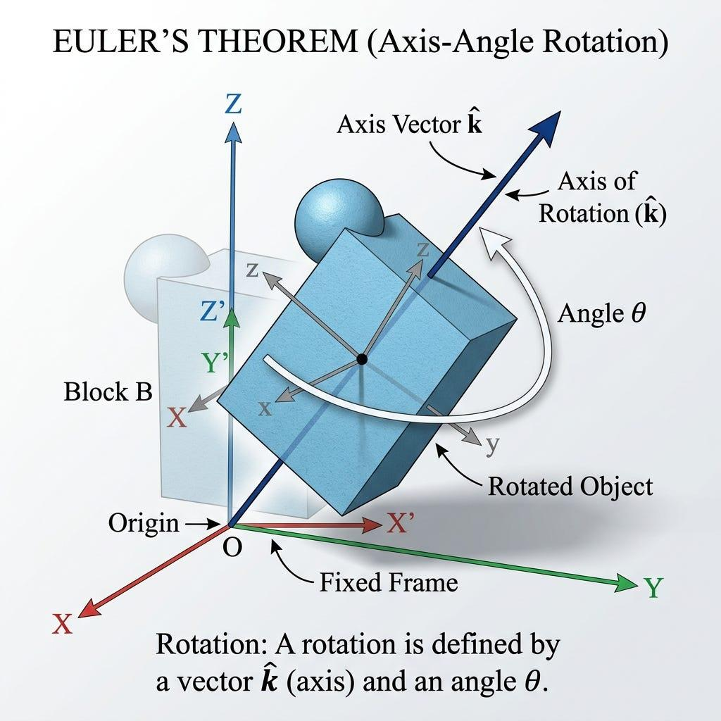
An Arbitrary Axis of Rotation is any straight line in space selected as the axis of rotation, regardless of its orientation relative to the coordinate system.
It can be described using a point on the line and a direction vector.

Types of Rotation According to the Rotation Angle
# Source: AI Source: Provided by: [Data Path: Persons Table -> ID Column: 1, Name_En Column: Motasem Essam] -> From: [ChatGPT] on [7/25/2026]
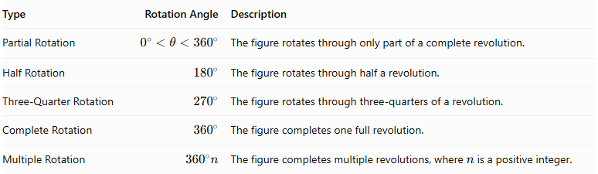
Type | Rotation Angle | Description
Partial Rotation | $$0^{∘}<θ<{360}^{∘}$$ | The figure rotates through only part of a complete revolution.
Half Rotation | $${180}^{∘}$$ | The figure rotates through half a revolution.
Three-Quarter Rotation | $${270}^{∘}$$ | The figure rotates through three-quarters of a revolution.
Complete Rotation | $${360}^{∘}$$ | The figure completes one full revolution.
Multiple Rotation | $${360}^{∘}n$$ | The figure completes multiple revolutions, where $n$ is a positive integer.
A complete ${360}^{∘}$ rotation is commonly used to generate a complete solid of revolution.

Mathematical Representation

Rotation Radius
# Source: AI Source: Provided by: [Data Path: Persons Table -> ID Column: 1, Name_En Column: Motasem Essam] -> From: [ChatGPT] on [7/25/2026]
The rotation radius is the perpendicular distance from a point to the axis of rotation.
For a point $P(x,y)$:
- Around the horizontal axis $y=0$:
$$r=|y|$$
- Around the vertical axis $x=0$:
$$r=|x|$$
- Around a horizontal axis $y=k$:
$$r=|y−k|$$
- Around a vertical axis $x=h$:
$$r=|x−h|$$

Circular Path
# Source: AI Source: Provided by: [Data Path: Persons Table -> ID Column: 1, Name_En Column: Motasem Essam] -> From: [ChatGPT] on [7/25/2026]
A point at a perpendicular distance $r$ from the axis follows a circular path.
Circumference:
$$C=2πr$$
Area of the circular path:
$$A=πr^{2}$$

Rotation Angle
# Source: AI Source: Provided by: [Data Path: Persons Table -> ID Column: 1, Name_En Column: Motasem Essam] -> From: [ChatGPT] on [7/25/2026]
The rotation angle can be measured in degrees or radians.
$${360}^{∘}=2π \text{radians}$$
The angular displacement is represented by:
$$θ$$

Rotation Around the Coordinate Axes
# Source: AI Source: Provided by: [Data Path: Persons Table -> ID Column: 1, Name_En Column: Motasem Essam] -> From: [ChatGPT] on [7/25/2026]
For a point $(x,y,z)$, rotation around the $z$-axis by angle $θ$ gives:
$$x'=xcosθ−ysinθ$$
$$y'=xsinθ+ycosθ$$
$$z'=z$$
The corresponding rotation matrix is:
$$R_{z}(θ)=beginbmatrixcosθ\&−sinθ\&0\backslash sinθ\&cosθ\&0\backslash 0\&0\&1endbmatrix$$
This matrix describes the rotational transformation of points around the $z$-axis.

Mathematical Properties
# Source: AI Source: Provided by: [Data Path: Persons Table -> ID Column: 1, Name_En Column: Motasem Essam] -> From: [ChatGPT] on [7/25/2026]
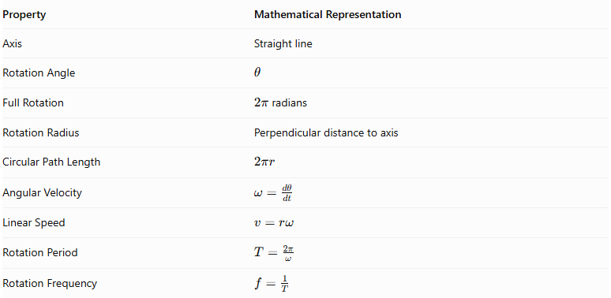
Property | Mathematical Representation
Axis | Straight line
Rotation Angle | $$θ$$
Full Rotation | $2π$ radians
Rotation Radius | Perpendicular distance to axis
Circular Path Length | $$2πr$$
Angular Velocity | $$ω=\frac{dθ}{dt}$$
Linear Speed | $$v=rω$$
Rotation Period | $$T=\frac{2π}{ω}$$
Rotation Frequency | $$f=\frac{1}{T}$$

Applications in Solid Geometry
# Source: AI Source: Provided by: [Data Path: Persons Table -> ID Column: 1, Name_En Column: Motasem Essam] -> From: [ChatGPT] on [7/25/2026]
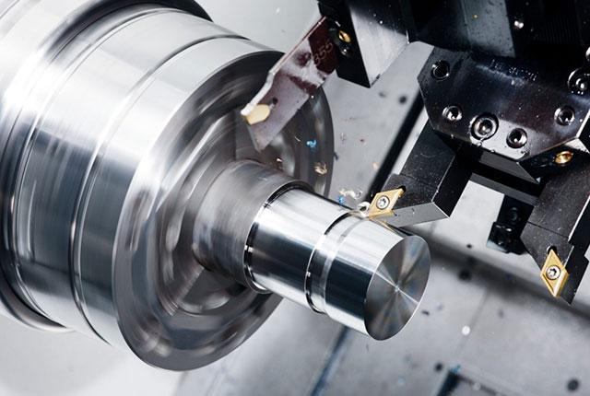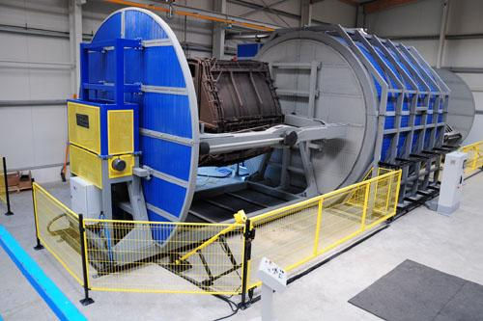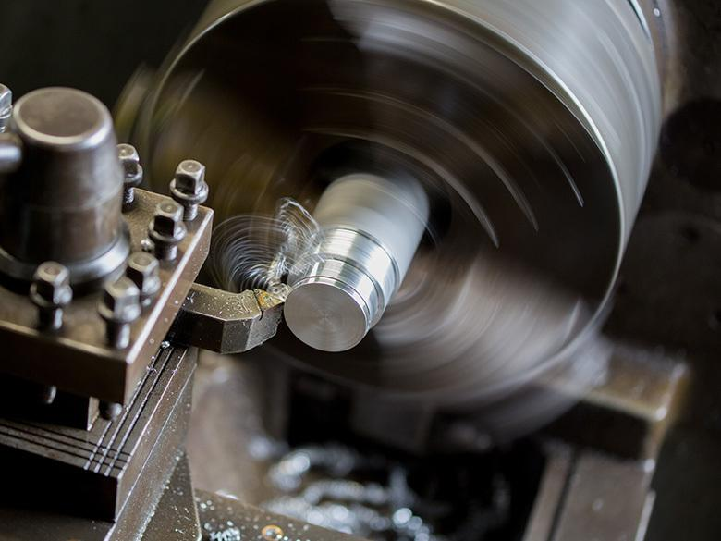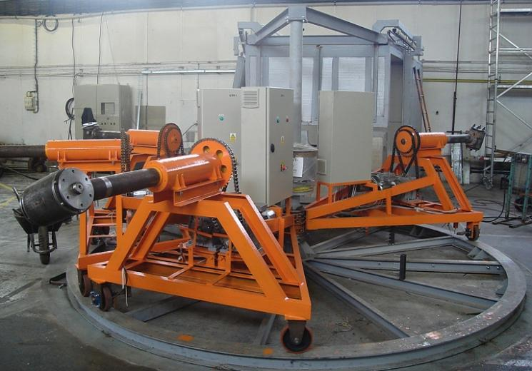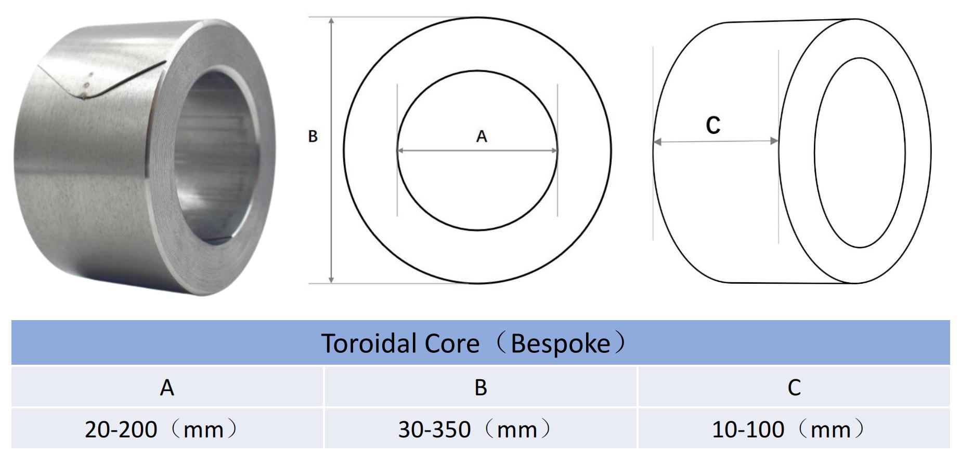
- Solid Generation: Producing cylinders, cones, spheres, spheroids, and toroidal solids.
- Geometric Modeling: Defining the shape and dimensions of solids of revolution.
- Mechanical Engineering: Designing rotationally symmetric machine components.
- Manufacturing: Controlling the rotation of workpieces in lathe operations.
- Architecture: Designing domes, columns, and rotationally symmetric structures.
- Mathematical Analysis: Calculating surface areas and volumes using integration.

Main Classification
# Source: AI Source: Provided by: [Data Path: Persons Table -> ID Column: 1, Name_En Column: Motasem Essam] -> From: [ChatGPT] on [7/25/2026]
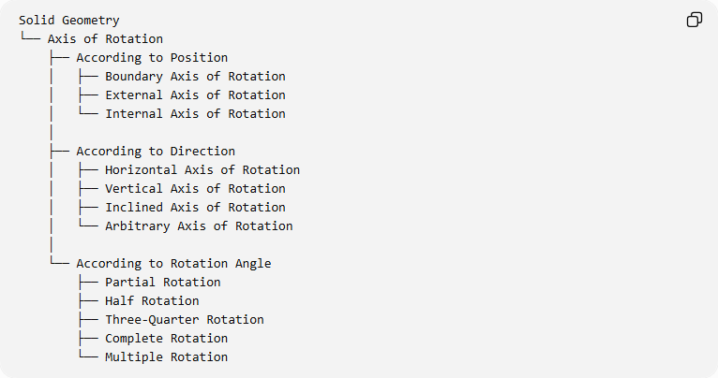
Solid Geometry
└── Axis of Rotation
├── According to Position
│ ├── Boundary Axis of Rotation
│ ├── External Axis of Rotation
│ └── Internal Axis of Rotation
│
├── According to Direction
│ ├── Horizontal Axis of Rotation
│ ├── Vertical Axis of Rotation
│ ├── Inclined Axis of Rotation
│ └── Arbitrary Axis of Rotation
│
└── According to Rotation Angle
├── Partial Rotation
├── Half Rotation
├── Three-Quarter Rotation
├── Complete Rotation
└── Multiple Rotation

Key Points
# Source: AI Source: Provided by: [Data Path: Persons Table -> ID Column: 1, Name_En Column: Motasem Essam] -> From: [ChatGPT] on [7/25/2026]
- The axis of rotation is the fixed line around which a geometric figure rotates.
- It determines the position and direction of the rotational movement.
- Points on the axis remain stationary.
- Points outside the axis follow circular paths.
- The perpendicular distance from a point to the axis determines its rotation radius.
- The axis can be classified according to its position, direction, and rotation context.
- A complete rotation is ${360}^{∘}$ or $2π$ radians.
- The axis of rotation is a fundamental element in generating solids of revolution.

Conclusion
# Source: AI Source: Provided by: [Data Path: Persons Table -> ID Column: 1, Name_En Column: Motasem Essam] -> From: [ChatGPT] on [7/25/2026]
The Axis of Rotation is a fundamental geometric element used to describe and construct rotational movements in solid geometry. It defines the fixed line around which a plane region or geometric figure rotates, determining the resulting three-dimensional shape.
Its position, direction, and orientation influence the generated solid, making it essential for understanding solids of revolution, rotational surfaces, and their mathematical properties.

Sources
# Source: AI Source: Provided by: [Data Path: Persons Table -> ID Column: 1, Name_En Column: Motasem Essam] -> From: [ChatGPT] on [7/25/2026]
- Illustrative Mathematics – Axis of Rotation.
- Math Open Reference – Axis.
- Math Is Fun – Solid of Revolution.
- Istanbul Technical University – Rotational Sweeps.

